University of Plymouth
School of Engineering, Computing, and Mathematics

COMP3000 2024/2025

AnchoredMind – Exploring underutilised technologies in anxiety prevention and treatment

Benjamin Andrew Hanley

10721130

BSc (Hons) Computer Science

Github
https://github.com/b-a-hanley/AnchoredMind

Project Vision

Problem statement
In a technological era such as today, anxiety disorders are the most prevalent mental health issue with an estimated 301 million people suffering from anxiety in 2019 (World Health Organization, 2023). (Elliot and Dweck, 2013) and there is an increased demand on mental health sector with two in five patients forced into needing emergency services (Royal College for Psychiatrists, 2020). The currently available mobile technologies which target providing care to people with anxiety use text-based CBT approaches. Whilst these have been proven successful psychological techniques in relation to technology, these techniques have hardly utilised the capabilities of the technology. Currently 67.3% of anxiety apps lacked development with health care professionals, and only 3.8% were tested thoroughly. (Sucala et al., 2017).

The vision
Anchored Mind is an anxiety management app designed to innovate the use of technology in the prevention and treatment of anxiety. This project will have a strong emphasis on liaising with health care professionals in differing areas with the specialism of anxiety. Discovering unthought-of technological capabilities of phones and ideating with healthcare professionals’ different software solutions that can further care in innovative ways. The app will explore the use of haptic feedback and sound creating an immersive experience that will offer comfort through repetitive, reliable stimulation. The app integrates with wearable heartrate monitoring to support mood tracking as well as building supporting evidence in the effectiveness of the app. The development will emphasise human-computer interaction principles to ensure the app is calming and suitable in healthcare. The effectiveness of the app will be assessed through rigorous testing, adhering to psychological best practices while balancing budget and time constraints. Finally, I will evaluate whether the app meaningfully contributes to anxiety treatment and psychology.

Table of Contents
Github 2
Project Vision 2
Problem statement 2
The vision 2
Introduction 4
Development Environment 4
Frontend 4
Backend 5
Database 5
Integrated Development Environment 5
Version Control 6
Risk Plan 6
Proposed Gantt chart 9
9
Project Backlog 9
Development issues: 10
Literature Review 10
Project Background 10
What is an Anxiety Disorder? 10
What is CBT? 10
Current Anxiety Management apps 12
Discussion of Legal, Social and Ethical principles 13
General Data Protection Act 2018 13
Methodology 13
Consultation with Healthcare professionals 13
Why there is healthcare consultation? 13
Who are the healthcare consultants? 14
How I will consult 14
Should, Would, Could structure 14
High-level Gant chart 16
Design 18
Mood board 18
Personas 18
Rounded edges 20
Colour Choices and Scheme 20
Accessibility 21
App Map 22
Breath 23
High Fidelity prototype 23
First Semi-Structured Design Case Study 23
Offline/online 25
Implementation 25
Multi-language 25
Video Player 25
Audio player 25
Haptic feedback 26
Garmin watch 26
References 26
Appendencies 29
Sebastian Weckwerth Meeting 1 – Minutes 29
Becca Horner Meeting 1 - Minutes 30
Alyson Norman Meeting 1 – Minutes 32

Introduction

Development Environment

Frontend

Flutter – Flutter is an open-source framework for building natively compiled app for multiple platforms including android, iOS, macOS and Windows from a single codebase. Built by Google, Flutter code compiles to ARM or Intel machine code as well as JavaScript, for fast performance on any device (Flutter, 2024). It uses the easy-to-learn dart programming language. Flutter should be used due to fast development (Windmill, 2020). The hot reload rapidly reduces the development time.

React Native – React native allows for development across android, iOS, MacOS, windows and web. Code is written in JavaScript and TypeScript and rendered by native device code. This open-source framework developed by Meta manages different platforms using a virtual DOM that is a mapped to a real DOM tree to boost performance.

Flutter Vs React Native

Feature | Flutter | React Native
Programming Language | Dart | JavaScript/TypeScript
Rendering | Skia engine | Native components
Performance | Faster for custom UIs | May lag for heavy UIs
Learning Curve | Steeper due to Dart | Easier for JS devs

AnchoredMind should adopt for flutter for high performance when developing a custom UI, in addition the strength of Hot reloading rapidly cuts down the development time.

Backend

Express with Nodejs - Express is a minimal and flexible Node.js web application framework that provides a robust set of features for web and mobile applications (OpenJS Foundation, 2017). NodeJS can create servers, web apps, command line tools and scripts. It is an open-source JavaScript runtime environment that can run on many platforms (Node.js, 2023). It uses an asynchronous, non-blocking I/O model to be lightweight and efficient.

ASP.NET – Microsoft’s open source ASP.NET framework is known for its speed and efficiency thanks to optimised runtime and ability. It supports Model-View-Controller and APIs for building RESTful services. The language is primarily for C# (Microsoft, n.d.).

Express Vs ASP.NET – Due to my recent experience AnchoredMind will use an Express framework for an API due to time constraints, however given more development time, ASP.NET would be preferable due to its high performance (Mayank C, 2024).

Database

MongoDB - MongoDB is a document database with the scalability and flexibility that you want with the querying and indexing that you need (MongoDB, 2024). MongoDB allows you store information in JSON documents and is the most popular NoSQL Database option (Győrödi et al., 2022). Unlike relational databases, which rely on structured tables and predefined schemas, NoSQL databases are designed to handle diverse and unstructured data formats. With high read/write throughput and low latency, NoSQL systems ensure optimal performance even under massive workloads. NoSQL databases support horizontal scaling. This makes it easier and more cost-effective to scale as your data or user base grows.

MySQL – MySQL is

Integrated Development Environment

Version Control

The most universal programming version control

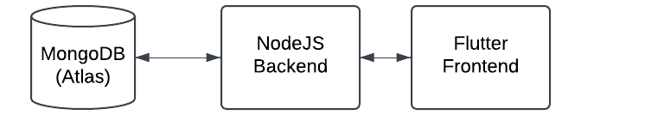

Risk Plan
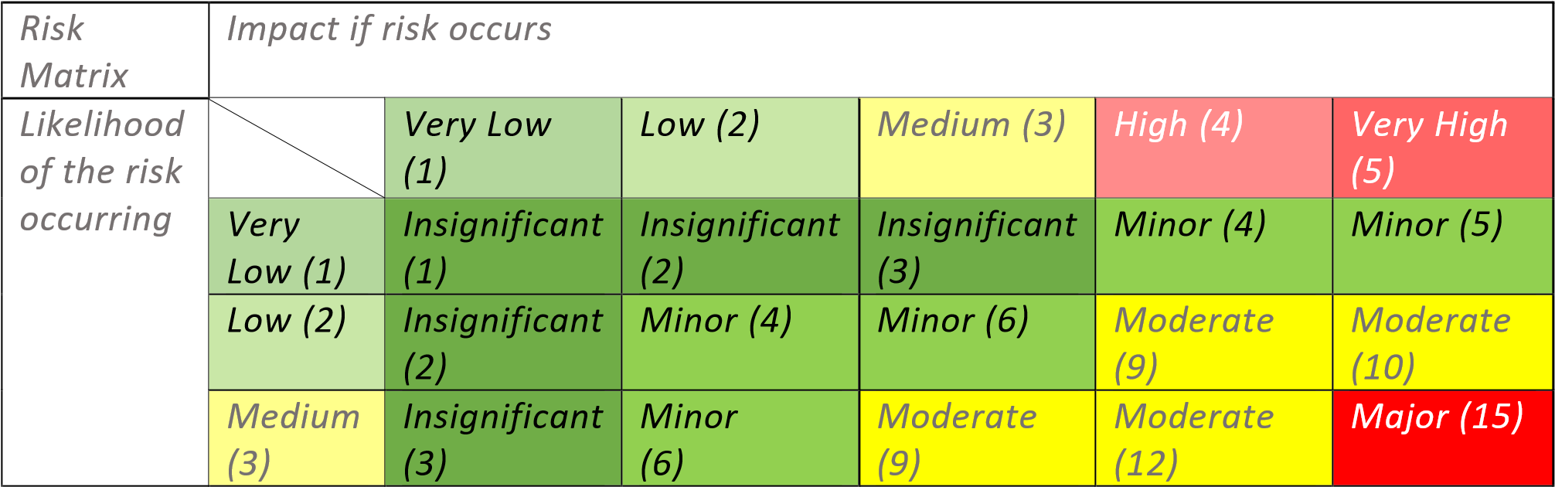
 | High (4) | Minor (4) | Moderate  (9) | Moderate  (12) | Major (16) | Severe (20)
 | Very  High (5) | Minor (5) | Moderate  (10) | Major (15) | Severe (20) | Severe (25)

ID | Risk  Description | Likelihood of the risk occurring | Impact if the risk occurs | Severity (according to risk matrix) | Possible impacts | Mitigating action
1 | Not enough time to complete project | Medium  (3) | Very High  (5) | Major (15) | Limits quality of work, Errors or faults may not be resolved. | Writing a comparative  Analysis of  Would,  Should, and  Could  Ensuring enough time is spent on the project
2 | Balancing other modules | High (4) | High (4) | Major (16) | Enough time won’t be given to the project limiting its quality | Ensure each module has a day dedicated for in the week
s3 | Not enough  testing is  completed | High (4) | Medium  (3) | Moderate  (12) | Product may contain unknown  faults; Care cannot be effectively assessed | Ensure that all work is finished one month before deadline to allow for comprehensive testing.  Technical tests  are to be made  incrementally along with code.
4 | Scope Creep | Low (2) | High (4) | Moderate  (8) | Product may increase in size causing issues with completion | Writing a comparative  Analysis of  Would,  Should, and  Could grasping
 |  |  |  |  |  | what is essential in the time frame.
5 | Learning an unfamiliar programming language | Very High  (5) | Low (2) | Moderate  (10) | Can cause delays in development time | Factor in time of learning a  new language  in  development
6 | Working with  client liaisons | Very High  (5) | Low (2) | Moderate  (10) | Delays caused by unavailability  of liaisons  May ask for project changes | Meet on frequent basis  and all meetings booked far in advance.  Explain problems faced in development
7 | Budget  Constraints | High (4) | Moderate  (3) | Moderate  (12) | Testing and Research is limited by funds | Use as many free, opensource resources. Utilise personal connections in testing.
8 | Health and personal factors | Very Low  (1) | High (4) | Minor (4) | Unknown  Reasons but any health or personal factors  would be  serious for it to prevent work | Ensure good work, mental, spiritual, physical health is maintained throughout final year
9 | Hardware  failure | Low (2) | Very High  (5) | Moderate  (10) | Damage to computer would cause delays | Earliest sign of hardware deterioration, buy a new device
10 | Unforeseen factors | Very Low  (1) | Moderate  (3) | Insignificant  (3) | Unforeseen and unknown | Unforeseen

Proposed Gantt chart
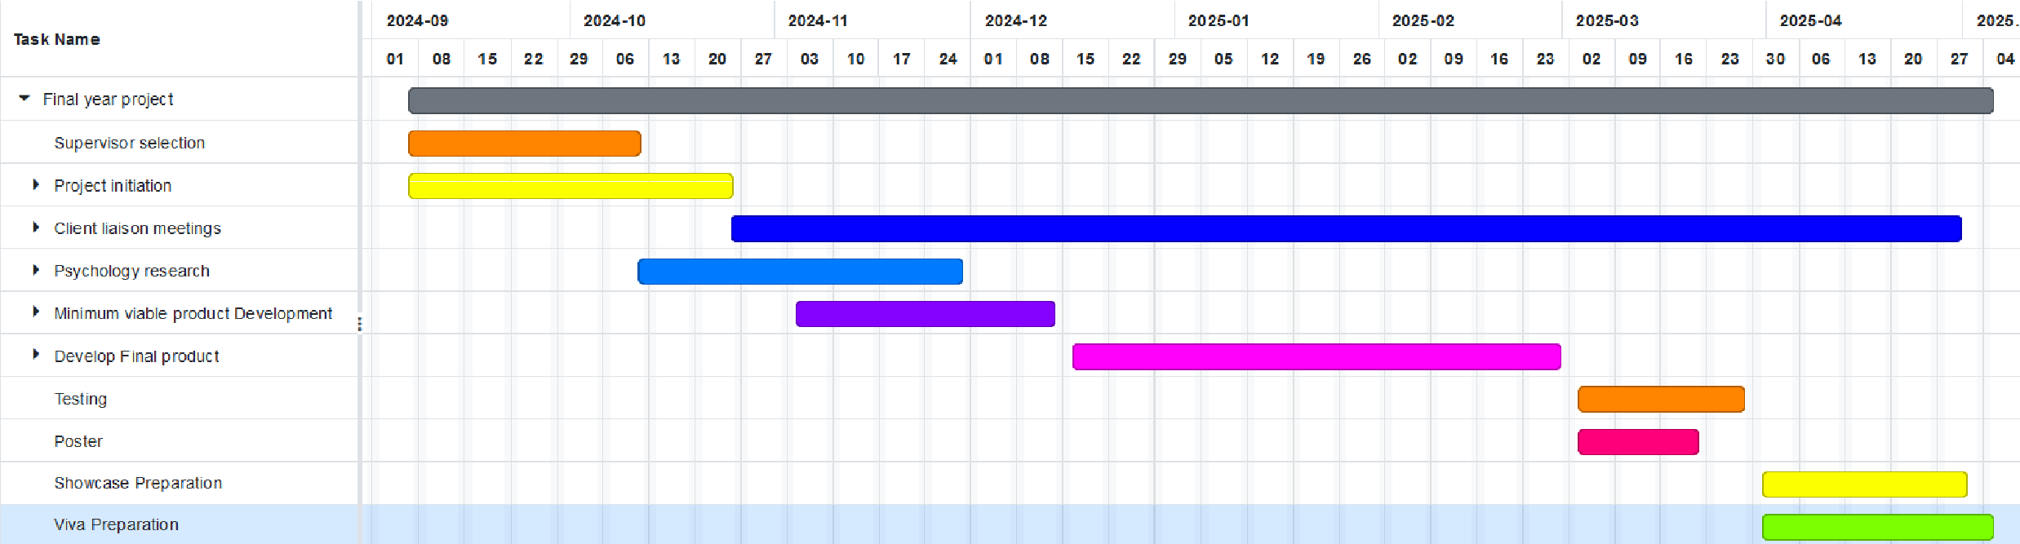

Project Backlog

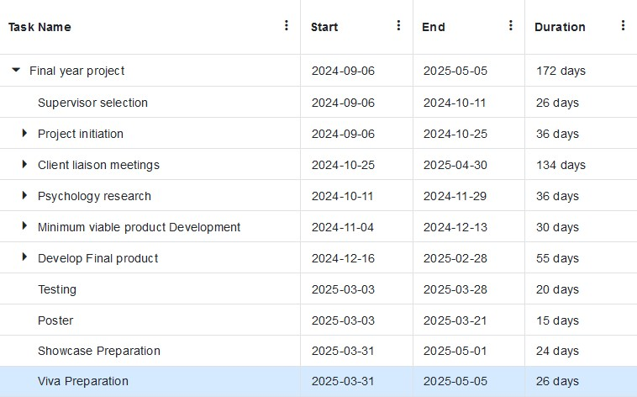

Trelloboard:
https://trello.com/invite/b/671b95c3ea97f4ff2940f6a9/ATTI02cd16249b4ad1545c34e5cf92 af12d91F88DEC8/my-trello-board

Development issues:
Computer issues 5 days
- Computer crashing and replacement

Significant Chest infection 16 days
- Rare case which left me unable to work

Coursework clashes 3 months
- full stack development module -2 months
- others combined -1 month

Personal factors 15 days

Other commitments 25 days
- Society commitments – 15 days
- Job applications – 5 days
- Religious commitments – 5 days

Watch issues 25 days
- Losing watch – 18 days
- Watch replacement -7 days

Literature Review

Project Background

What is an Anxiety Disorder?
The Diagnostic and Statistical Manual (also known as DSM-5, which is used to define the leading current psychological thought in mental health diagnostics) describes anxiety “as excessive worry and apprehensive expectations, occurring more days than not for at least 6 months, about a number of events or activities, such as work or school performance” (American Psychiatric Association, 2013).

What is CBT?
There are arrange of psychological treatments the most evidence-based treatment is Cognitive behavioural therapy (CBT) (Bandelow, Michaelis and Wedekind, 2017). It is a psycho-social intervention aiming to improve mental health conditions, especially depression and anxiety. CBT isn’t a set method but rather a framework to approach treating emotional disorders (Cherry, 2023). CBT is idiosyncratic based on its practitioner meaning can vary substantially.
CBT seeks to challenge participants cognitive distortions and associated behaviours. Cognitive distortions include Dichotomous thinking (All or nothing thinking), Over-generalising, Disqualifying the positive (focusing only on the negatives), Selective abstraction (mental filtering), Magnification or minimalization of opinions, jumping to conclusions, Catastrophising (taking things out of proportion), Emotional reasoning (taking feelings as fact) and many more (Oliverira, 2012; Yurica & DiTomasso, 2005). Here are the ways people understand negative thought processes work:
Component | Core Beliefs | Dysfunctional Assumptions | Negative Automatic Thoughts
Term definition | Core beliefs are deep fundamental, absolute beliefs that people assert about themselves, other people, about the world or the future (J. S. Beck, 2011; K. S. Dobson, 2012). These beliefs often centre around the concept of being loved or adequacy/helplessness. | Subconscious associations often fixed, conditional 'rules for living' that people apply to life. Often being the mediator to stress. | Opinions: Sometimes unconscious and habitual
Effect | When a belief is inaccurate or unhelpful it can disrupt their approach to life itself and lead them to make dysfunctional assumptions. (Wenzel, 2012). | They may build unhealthy lifestyles to meet the requirements of their assumptions and failure to meet this led to negative automatic thoughts | Validates and deepens Core belief
Example | “I’m Stupid”, “I’m undesirable”, “I’m trapped”, “I’m ugly” | “I must prove I’m not Stupid and undesirable by doing well in exams and getting marks.”  “I must get 1000 likes to prove I am not undesirable and not ugly” | I can’t get the answer correct; I can’t do this. Being consumed by their inability their Core belief is validated.  I can’t get enough likes, I am ugly.

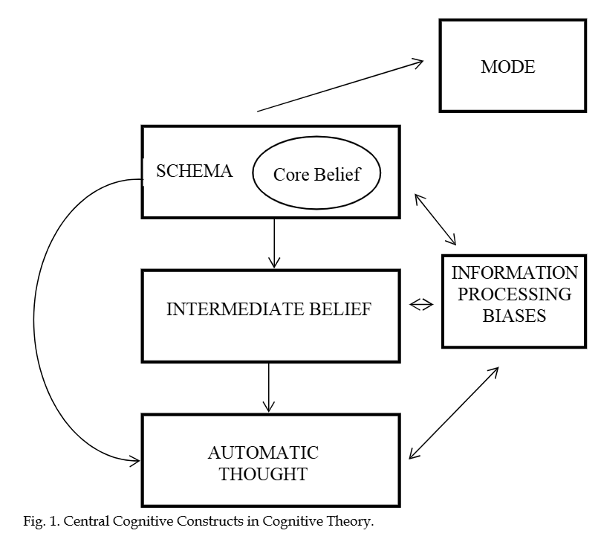
CBT aims to comprehend these beliefs, assumptions and thoughts and correct them through key components and strategies such as journaling, worksheets, goal setting, identifying dysfunctional cognitions and challenging them, and behavioural activation.
Feature Z The cognitive model shows the relationship of thoughts, assumptions and core beliefs (Wenzel, 2012),
cCBT (Computerised Cognitive behavioural therapy) can be an evidence-based method of providing CBT via a website or app. cCBT is a cost-effective method of providing care to people. Limited evidence can be found of other claims of geographic, time flexibility and reduction in waiting times. cCBT can found in many forms not only for interventions with therapists but including other resources. These resources have improved treatment adherence and lower attrition rates (Musiat and Tarrier, 2014). Studies have described this type of CBT can be beneficial for those with social anxiety and depression (Bessell et al., 2012).

Current Anxiety Management apps

Features | Anchored Mind | Calm | Headway | In Person therapy
Available 24/7 | ✔ | ✔ | ✔ | ✖
Available anywhere | ✔ | ✔ | ✔ | ✖
Breathing exercises | ✔ | ✔ | ✔ | ✔
Mood  Tracking | ✔ | ✔ | ✔ | ✖
Sensory grounding | ✔ | ✖ | ✖ | ✖
Psychologically tested | ✔ | ✖ | ✖ | ✔
Free | ✔ | ✖ | ✖ | Limited availability

The project is unique in the nature to exploring the use of haptic feedback in anxiety

Discussion of Legal, Social and Ethical principles

General Data Protection Act 2018

GDPR controls how personal information is processed by organisations and businesses. Information must be
- fair, lawful and transparent in use and purpose
- adequate, relevant and limited to what is necessary
- Accurate and where appropriate up to date.
- Stored for the shortest duration as relevant
- Ensures appropriate security
- Protected against unlawful and unauthorised processing, access, loss, destruction or damage of information

This project has stronger legal implications in being related to health and specifically mental health it represents more vulnerable people. The journalling feature may include sensitive information about race, ethnicity, political and religious beliefs, genetics, sex life or orientation.

Users have the right to
- Be informed of how data is being processed including third parties
- Access personal data
- Have incorrect data updated
- Have data erased
- Stop or restrict the processing of their data
- Data portability
- Object to how their data is being processed in certain circumstances

Methodology

Consultation with Healthcare professionals

Why there is healthcare consultation?
To set apart AnchoredMind from other apps, I will have regular meetings with healthcare professionals (Sucala et al., 2017). It is essential that the product for ethical reasons must only offer care if it is based on psychological understandings. These professionals will be able to critique and evaluate any aspects of the design and final product.

Who are the healthcare consultants?
It was important to have input from diverse psychology background giving a greater understanding from their own viewpoints. I am limited by how I was able to outreach to individuals given the nature of this dissertation having zero funding. These individuals I have built a rapport overtime and in the preparation of project initialisation were already consulted.

Alyson Norman is an Associate Professor of University of Plymouth, Academic Author and Associate Fellow of the British Psychological Society. Sebastian Weckwerth is a Clinical Nurse Specialist and DBT Practitioner at Children and Adolescent Mental Health Service (CAMHs). Rebecca Horner is a chartered educational psychologist and an Associate Fellow of the British Psychological Society.

Working with these accredited individuals will provide a cohesive and coherent understanding of anxiety. Each provides a diverse level of expertise but with a prominence in in younger adult and adolescents due to Dr Horner and Mr Weckwerth working with the same age group.

How I will consult
I will meet each consult once a month for a 30-minute meeting in which I will receive ideas, be educated on psychology and anxiety, ensure the product is psychologically based and to evaluate the product on a working and psychological level. These will operate as scrum meetings.

Summary of Mr Weckwerth Meeting 1

He described there is a lack of accessible apps, the most comprehensive apps require subscriptions or in app purchases. Most apps are aimed corporately to gain profit rather than consumer focussed providing the psychologically beneficial resource.

He defined anxiety and described his role and how he practices DBT. DBT is practice of building emotional literacy and helping people develop healthy coping strategies.

Should, Would, Could structure

Should – Essential requirements
Would - Optional requirements
Could – Ideal requirements

- Home page
  - App bar
    - Backbutton
    - Logo
    - Profile page
  - Navigation to other pages
  - Cards
- Gratitude/Journal Entries
  - Forms
  - Database connectivity
  - RecycleView
    - Delete entry
  - New entry button
  - Search and filters
- Customisations
  - Connectivity with watch
  - Daily Notifications
  - Multilanguage
  - Adjustable Font size
  - Colour themes
- Haptic
  - Haptic feedback
  - Haptic feedback patterns
  - Heartrate recording
  - Indexing Haptic based on heartrate
  - Downloadable haptic
  - Custom patterns
    - Spotify integration
    - Bass frequency detection
    - Microphone recording
- Breathing page
  - Local looping video
  - Animation
- Mindfulness page
  - Search
  - Audio player
    - Play/stop button
    - Time slider
    - Backwards button
    - Forwards button
  - Audios
  - Downloadable audio
- Tactile games
- Accelerometer based game
- Testing
  - Unit
  - Integration
  - CI/CD pipeline

High-level Gant chart
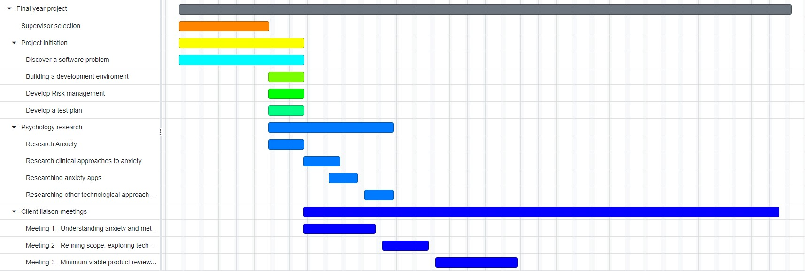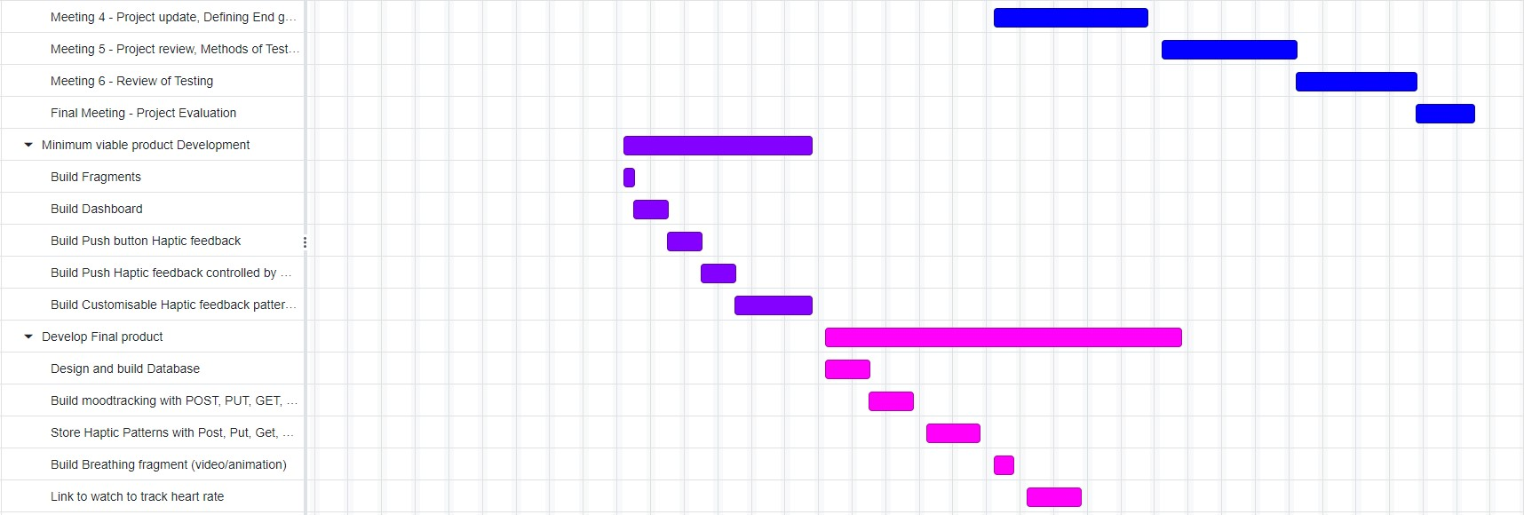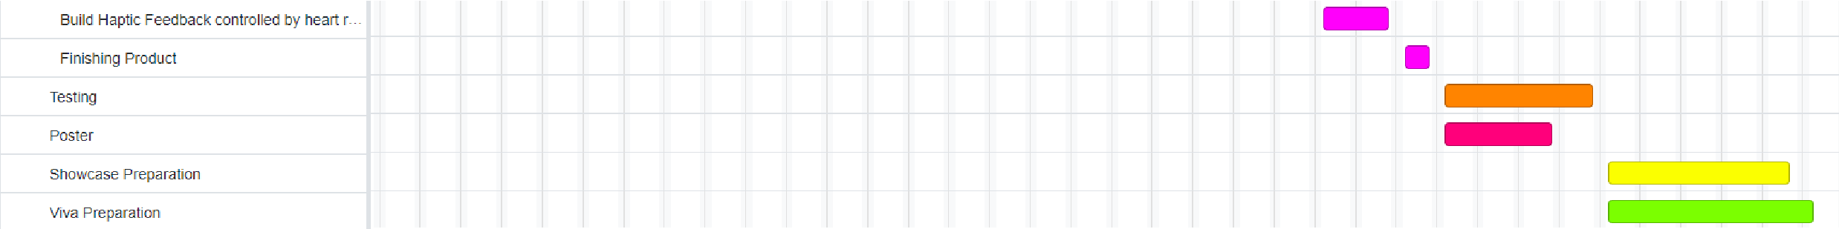

High-level project backlog
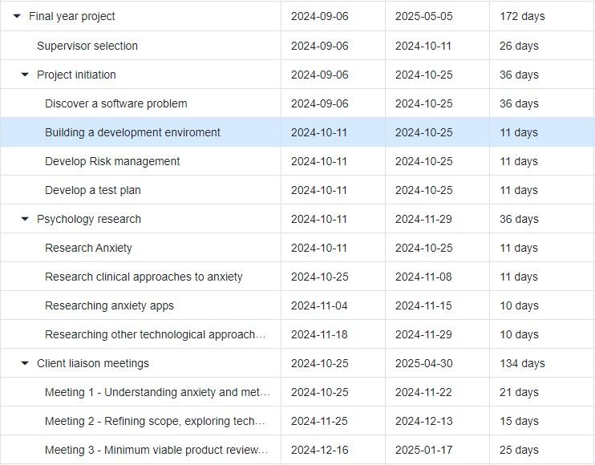
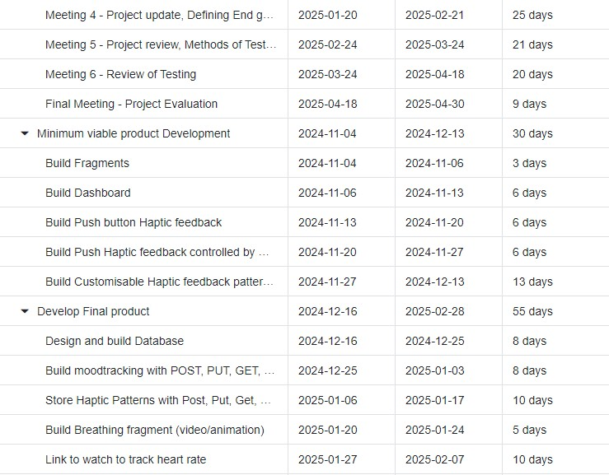
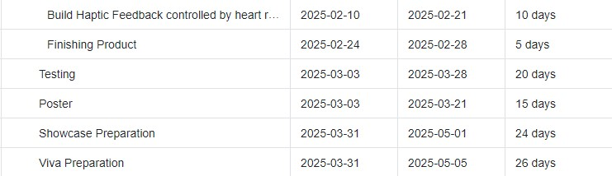

Design

Mood board
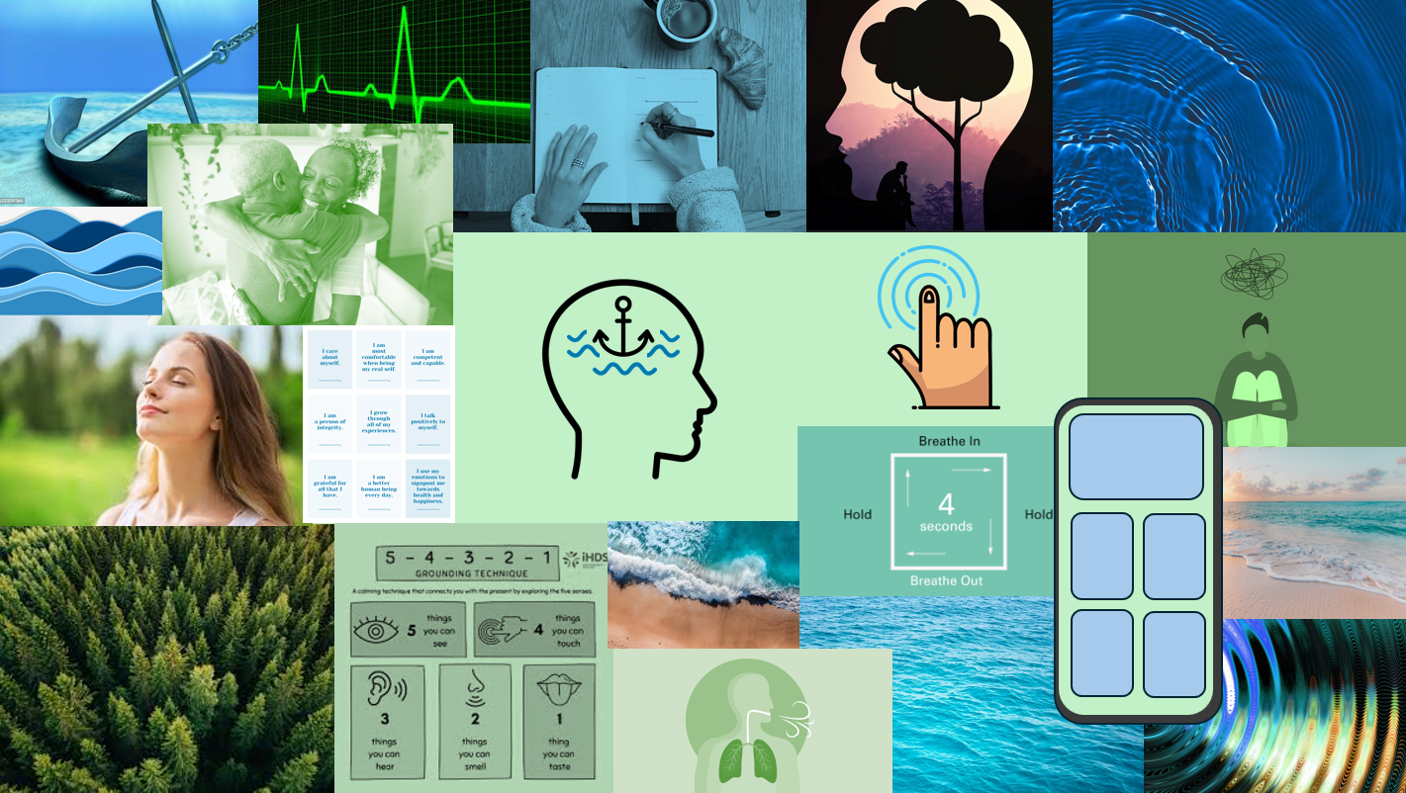

TODO: Add App drawings
Personas
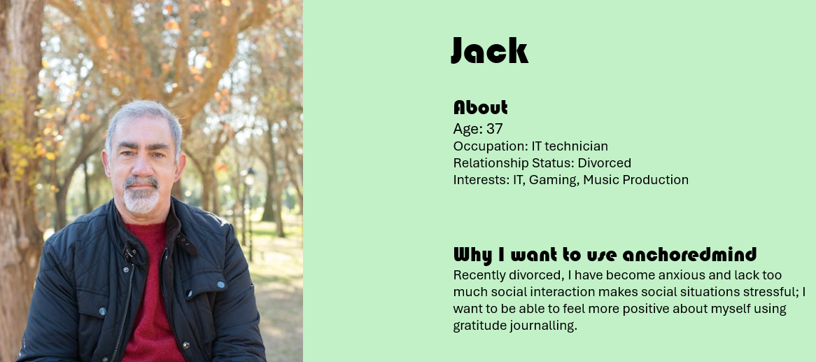
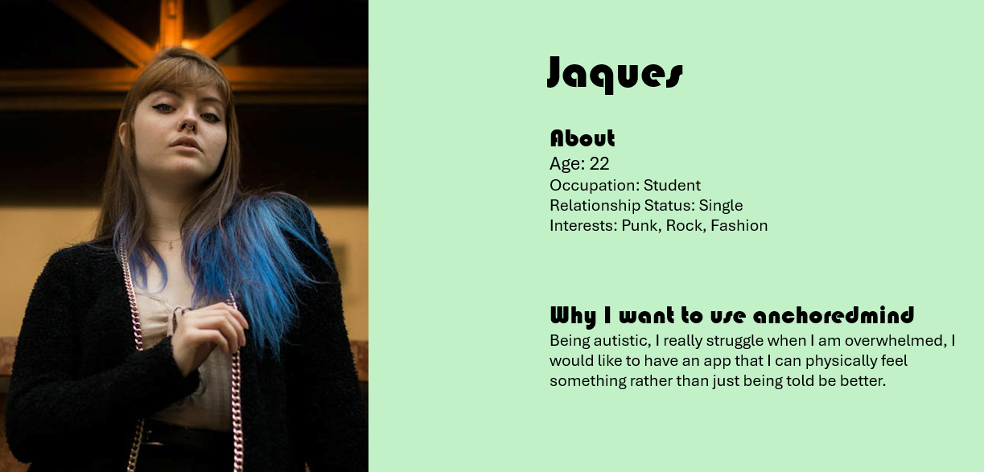
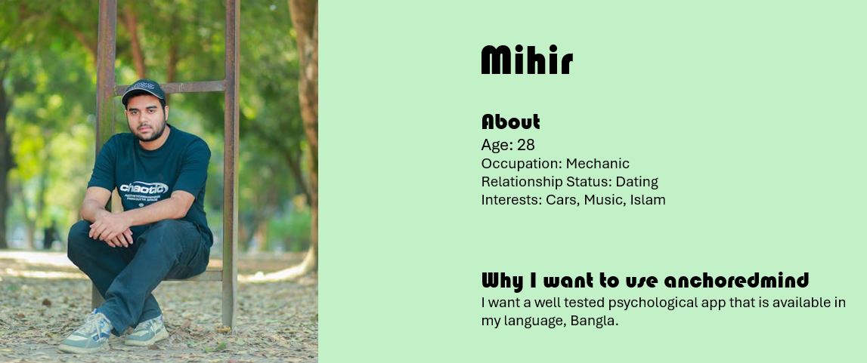
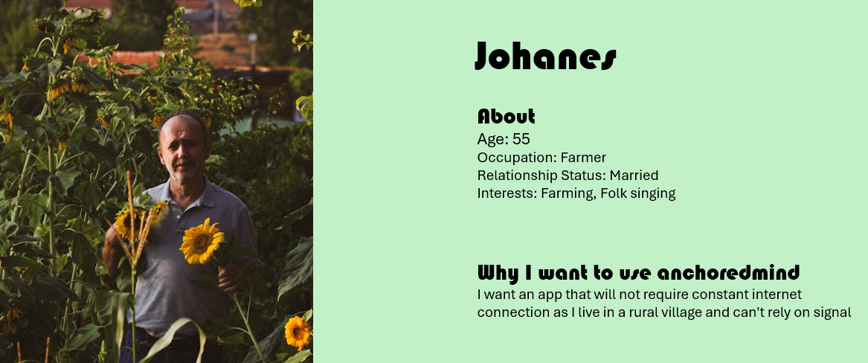
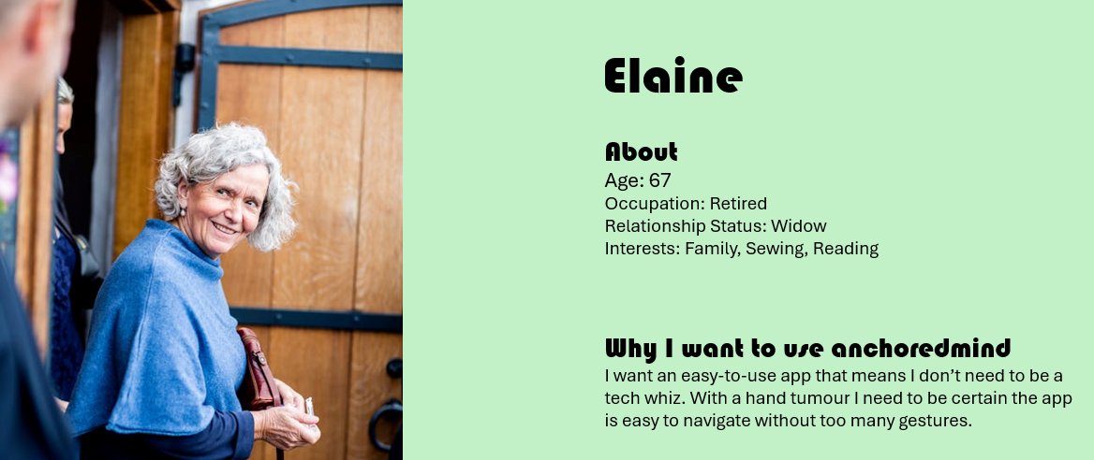

Rounded edges

AnchoredMind will have a consistent appearance by use of rounded widgets, for people’s emotions are affected by shapes (www.waltdisney.org, n.d.), Rounded edges appear friendlier due to the brain being conditioned to perceive sharp objects as harmful (Tey, 2022). Neuroimaging has shown the natural preference towards rounded edges over sharper objects (Bar and Neta, 2007). Round edges are easier on eyes to process and save space (Tey, 2022). In my app I will signify buttons using larger radiuses of the edges to draw the user to interact with it.

Colour Choices and Scheme

For an anxiety and mental health app the colour choices must be calming and restorative.
Blue, Green are thematically associated with being peaceful, gentle, calming and pleasant (Hilliard, 2013). Cool colours like blue appear to be preferred across many cultures (Hemphill, 1996).
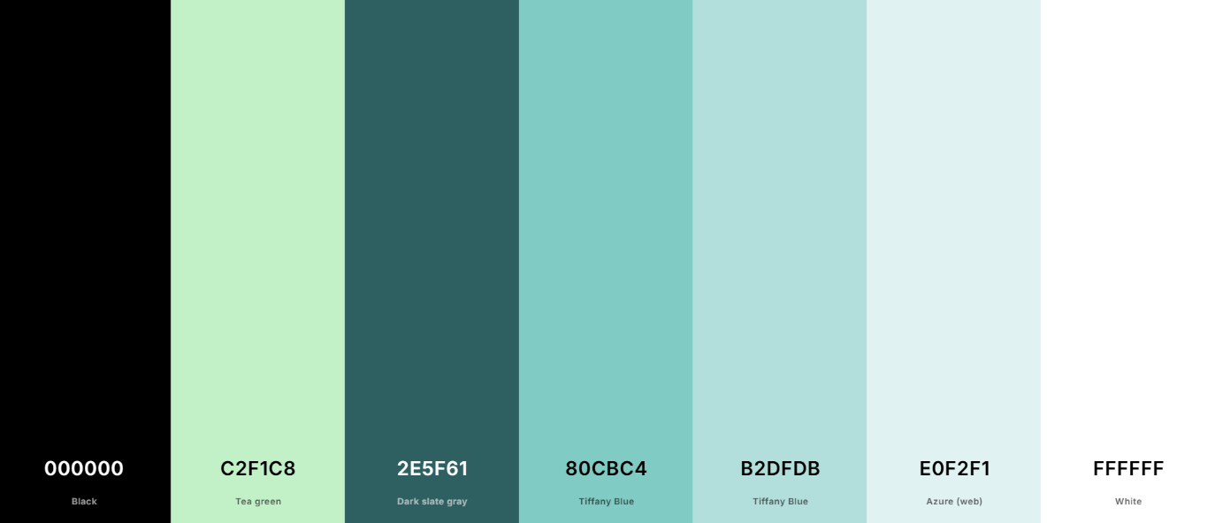
How Considering the name Anchoredmind and the correlation between Anchors and water, blue would be an appropriate branding choice. The app will hence use combination of blue and green.
Colour scheme

Accessibility

Colour
The text colours of white and black have suitable coloured backgrounds fitting to Web Content Accessibility Guidelines (WCAG) conventions. To ensure this I ran each other of the text colours against possible background colours using the WebAIM: Contrast Checker.
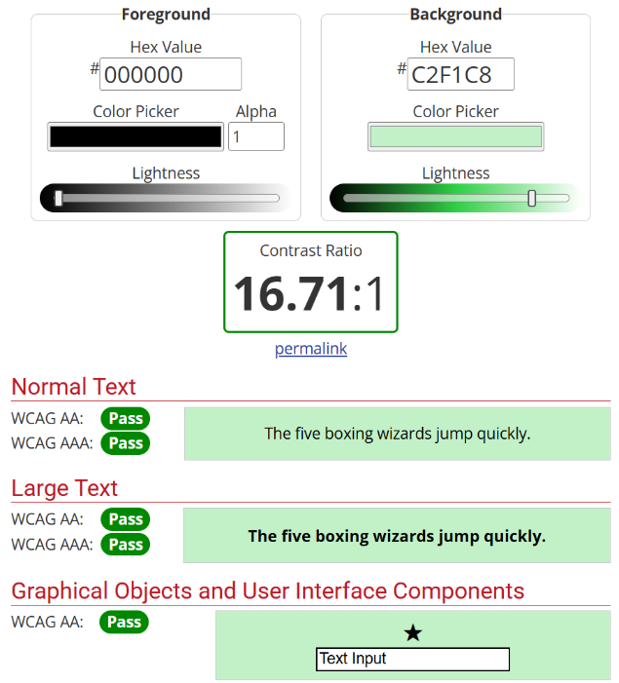
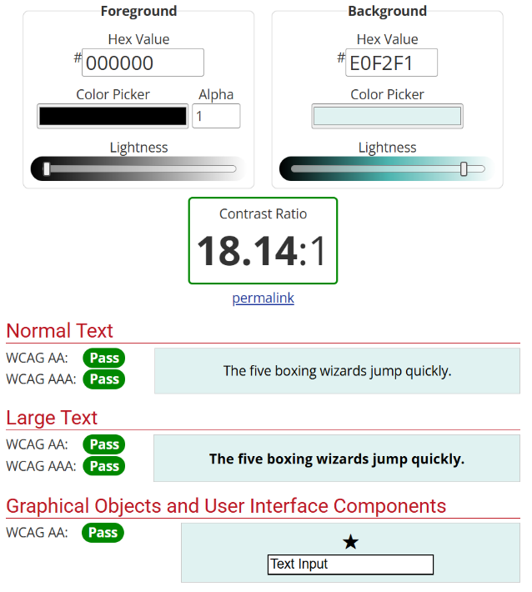
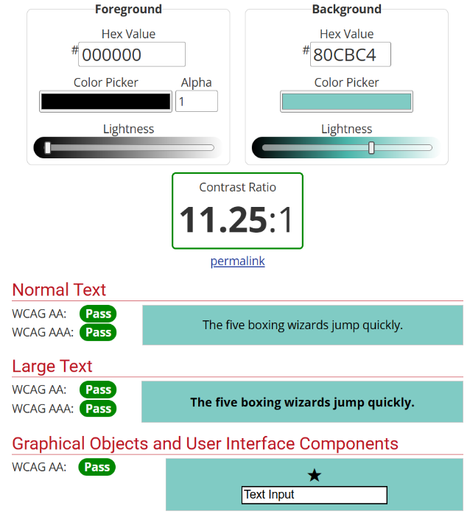
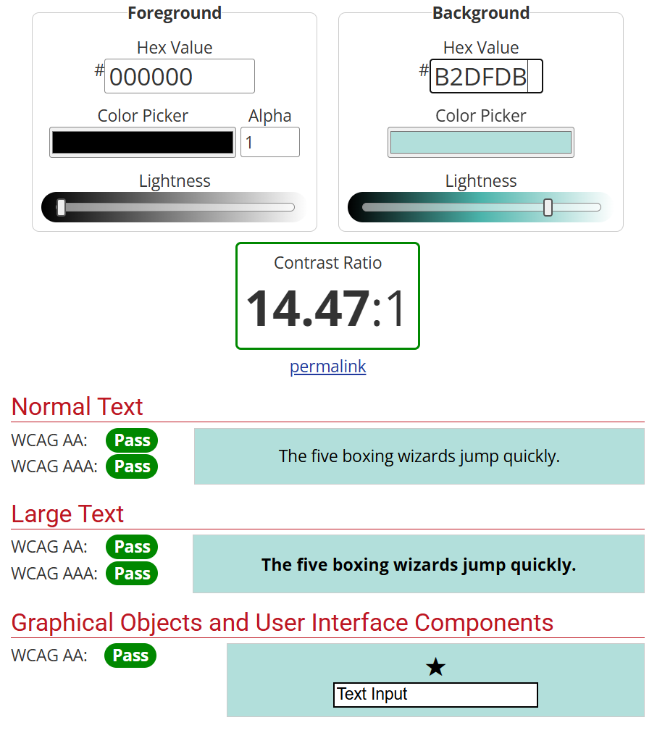
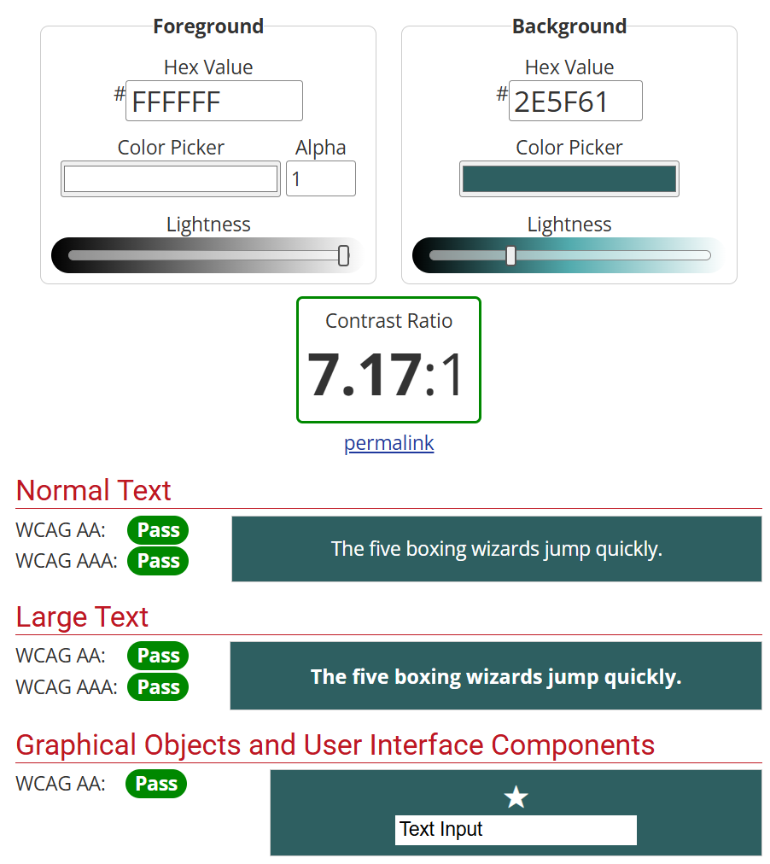

Language
AnchoredMind must use the most universal terms so that people with no psychology experience, non-native speakers, or people who have learning difficulties may better understand language. The use of Icons is present so that in absence of an available language, navigation through the app is still possible.

To accommodate to the greatest number of people it is my intent that the app should be multi-lingual. To have the greatest coverage in understanding I have chosen: English,
Mandarin Chinese, Hindi, Arabic and Bengali. The app must make considerable alterations including translations, data/number formatting and bidirectional text.

App Map
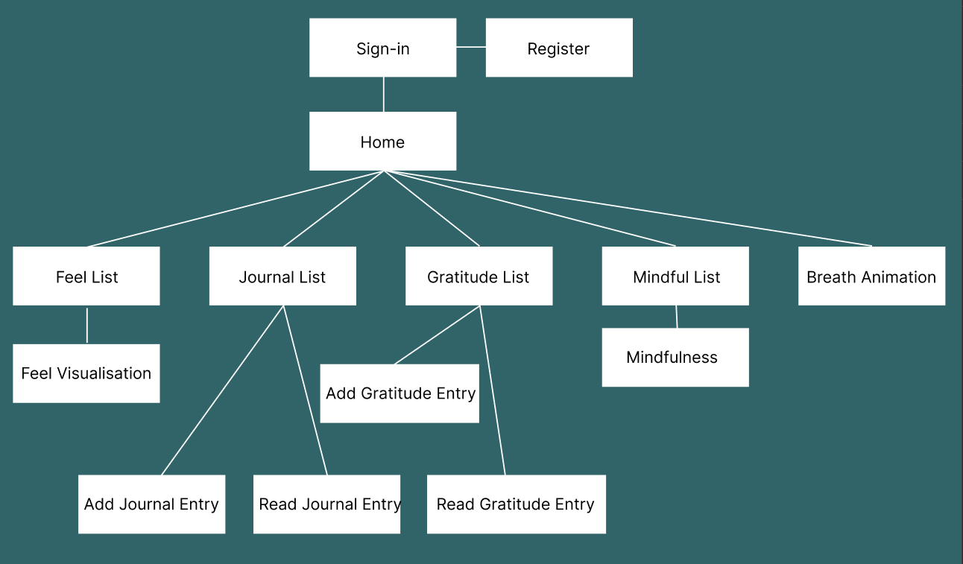

Breath
Currently the use of box breathing is used in psychology and is often animated in two approaches, in the figure below labelled variant 1 and variant 2
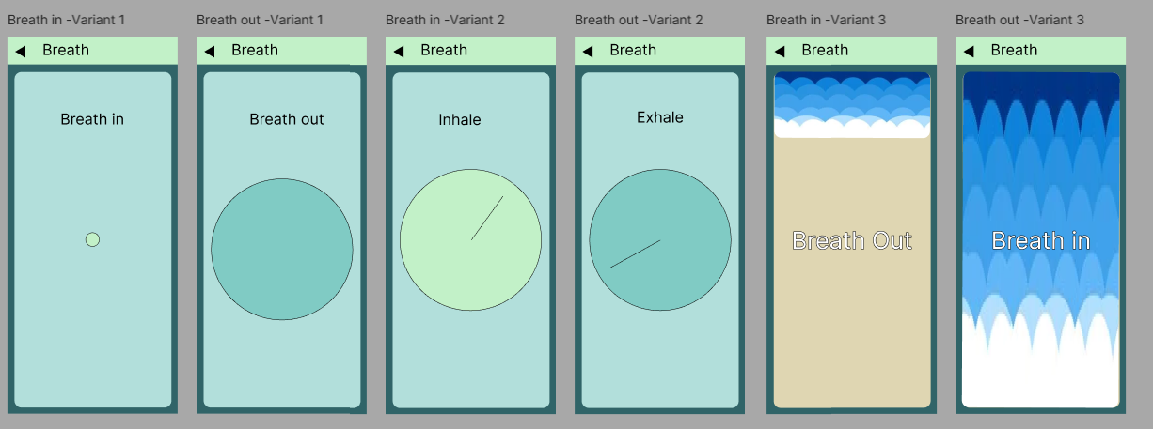

Through my experience of using these apps I felt disillusioned with the use of animation of simplistic shapes, taking a preference with variant 1 for a smooth animation of increasing and decreasing size of circle to align with breathing in and out. Given nature is often seen as a relaxing and calming, I searched nature for a cyclical expression that could represent and aid box breathing. Waves on a shore perfectly reflect this often noted as relaxing this would present calmness but also the anticipation of waves coming in out could aid box breathing. To ensure the animations were helpful with breathing, I developed animations using PowerPoint morph transition feature and recruited participants to feedback how they felt.

High Fidelity prototype
Anchoredmind – Figma

First Semi-Structured Design Case Study
To ensure the best design decisions were made I consulted with a computer science student to see what he had thought about design decisions. With his experience in Figma, I allowed him to replicate the designs with the changes he wanted to happen.
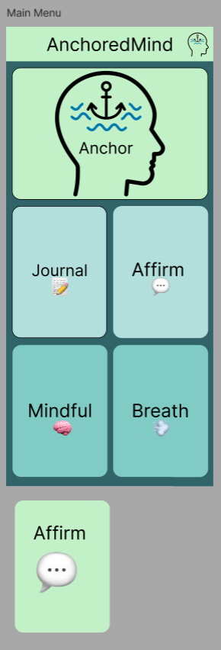
In reference to figure Y “Yeah I like the design of the homepage its easy to use, I would however make the icons this much larger (figure Z) as the whitespace of the buttons isn’t being used.”

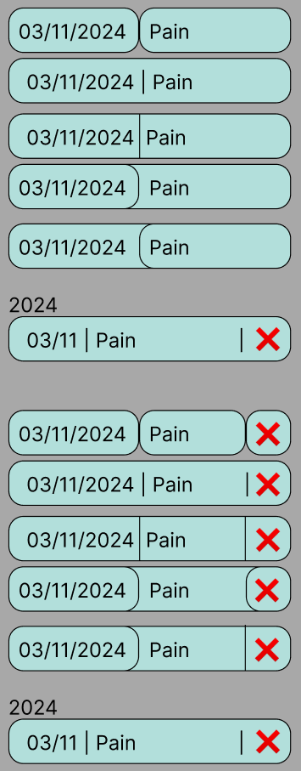
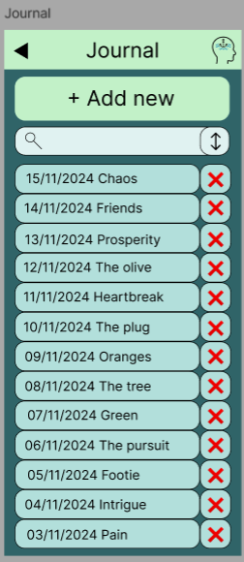
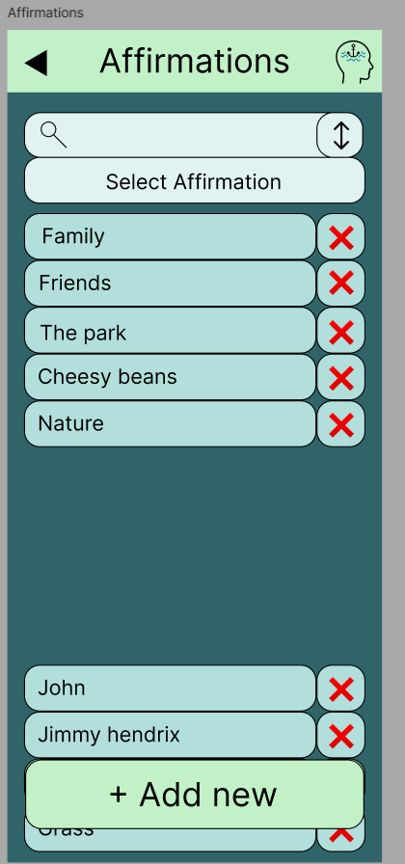
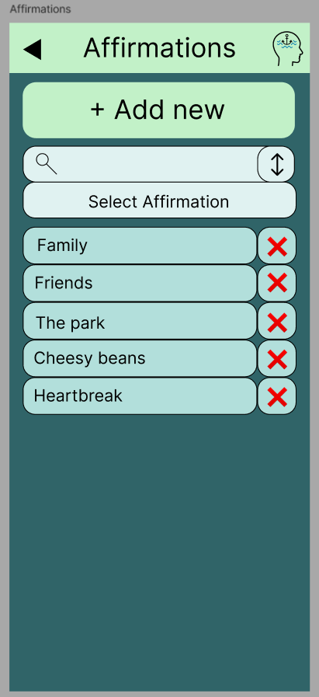
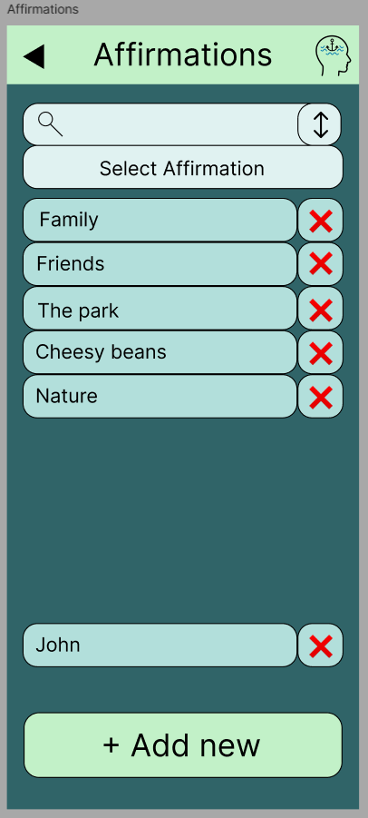
Breadcrumbs, text size scaling

Offline/online
Many apps now require internet to load data, this gives an advantage of requiring less storage. However, given the product is made to support vulnerable individuals the app must be thoughtfully designed. It must allow any individual not connected to internet the opportunity to receive as much of the app as possible. People who benefit from this design are travelling or people who live in remote rural villages. The app must balance mobile storage space and database calling. The app should be usable without signing in although some features such as journalling must require sign in to store data.

Implementation

Multi-language

Video Player

Audio player
The audio player is split of into two separate classes: the audio service class which handles the audio functionality and the audio player class which handles the audio user interface.

Audio service makes use of the audio players flutter package, which can play, pause, seek and stop a given audio.

Haptic feedback

Backend

Garmin watch
Connection of the Garmin watch could be done through several ways (Colour coding represents connection advantages and disadvantages):
- Garmin API
  - Online
  - Delayed access
  - Requires a commercial license
- Build a CIQ API
  - Live
  - Requires knowledge of Monkey C (Garmin Script Language)
- Garmin Broadcast Heartrate
  - Offline
  - Live
  - Requires user to set up Garmin device
- Bluetooth Low energy
  - Offline
  - Live
  - Natural human interaction

Using Bluetooth Low Energy, the app must search for a Garmin device, and based on UUID detect the heartrate characteristic.

References
American Psychiatric Association (2013). Diagnostic and statistical manual of mental disorders. 5th ed. Boston: Pearson.
American Psychiatric Association (2023). What Are Anxiety Disorders? [online] Psychiatry.org. Available at: https://www.psychiatry.org/patients-families/anxiety-disorders/what-are-anxiety-disorders.
Arnold, E. (2022). Anxiety DSM-5 Criteria and Treatment Overview. [online] MedCentral.com. Available at: https://www.medcentral.com/behavioral-mental/anxiety/assessment-diagnosis-adherence-anxiety.
Bakker, D., Kazantzis, N., Rickwood, D. and Rickard, N. (2016). Mental Health Smartphone Apps: Review and Evidence-Based Recommendations for Future Developments. JMIR Mental Health, [online] 3(1), p.e7. doi:https://doi.org/10.2196/mental.4984.
Bandelow, B., Michaelis, S. and Wedekind, D. (2017). Generalized Anxiety Disorders. Dialogues in Clinical Neuroscience, 19(2). doi:https://doi.org/10.31887/dcns.2017.19.2.
Bar, M. and Neta, M. (2007). Visual elements of subjective preference modulate amygdala activation. Neuropsychologia, 45(10), pp.2191–2200. doi:https://doi.org/10.1016/j.neuropsychologia.2007.03.008.
‌
Beck, A. T. (1996). Beyond belief: A theory of modes, personality, and psychopathology. In P. Salkovskis (Ed.), Frontiers of cognitive therapy (pp. 1–25). New York, NY: Guilford.
Bessell, A., Brough, V., Clarke, A., Harcourt, D., Moss, T.P. and Rumsey, N. (2012). Evaluation of the effectiveness of Face IT, a computer-based psychosocial intervention for disfigurement-related distress. Psychology, Health & Medicine, 17(5), pp.565–577. doi:https://doi.org/10.1080/13548506.2011.647701.
Cherry, K. (2023). What Is Cognitive Behavioral Therapy (CBT)? [online] Verywell Mind. Available at: https://www.verywellmind.com/what-is-cognitive-behavior-therapy-2795747.
De Oliveira, I.R. ed., (2012). Standard and Innovative Strategies in Cognitive Behavior Therapy. InTech. doi:https://doi.org/10.5772/1161.
Elliot, A.J. and Dweck, C.S. (2013). Handbook of Competence and Motivation, First Edition. Guilford Publications.
Flauzino, M., Veríssimo, J., Terra, R., Cirilo, E., Durelli, V.H.S. and Durelli, R.S. (2018). Are you still smelling it? Proceedings of the VII Brazilian Symposium on Software Components, Architectures, and Reuse on - SBCARS ’18. doi:https://doi.org/10.1145/3267183.3267186.
Flutter (2024). Flutter - Beautiful native apps in record time. [online] Flutter.dev. Available at: https://flutter.dev/.
Győrödi, C.A., Dumşe-Burescu, D.V., Zmaranda, D.R. and Győrödi, R.Ş. (2022). A Comparative Study of MongoDB and Document-Based MySQL for Big Data Application Data Management. Big Data and Cognitive Computing, 6(2), p.49. doi:https://doi.org/10.3390/bdcc6020049.
Hemphill, M. (1996). A Note on Adults’ Color–Emotion Associations. The Journal of Genetic Psychology, [online] 157(3), pp.275–280. doi:https://doi.org/10.1080/00221325.1996.9914865.
Hilliard, B. (2013). Optimising Comprehension and Shaping Impressions COLOUR PSYCHOLOGY Section Title Page. [online] Seahorses Consulting. Available at: https://www.seahorses-consulting.com/DownloadableFiles/ColourPsychology.pdf.

Microsoft (n.d.). What is ASP.NET? | .NET. [online] Microsoft. Available at: https://dotnet.microsoft.com/en-us/learn/aspnet/what-is-aspnet.
MongoDB (2024). What Is MongoDB? [online] MongoDB. Available at: https://www.mongodb.com/company/what-is-mongodb.
Musiat, P. and Tarrier, N. (2014). Collateral outcomes in e-mental health: a systematic review of the evidence for added benefits of computerized cognitive behavior therapy interventions for mental health. Psychological Medicine, 44(15), pp.3137–3150. doi:https://doi.org/10.1017/s0033291714000245.
National Institute of Mental Health (2024). Any Anxiety Disorder. [online] NIMH. Available at: https://www.nimh.nih.gov/health/statistics/any-anxiety-disorder.

Node.js (2023). Node.js. [online] Node.js. Available at: https://nodejs.org/en.
NHS (2024). Generalised anxiety disorder (GAD). [online] nhs.uk. Available at: https://www.nhs.uk/mental-health/conditions/generalised-anxiety-disorder-gad/.
OpenJS Foundation (2017). Express - Node.js web application framework. [online] Expressjs.com. Available at: https://expressjs.com/.
Royal College of Psychiatrists (2020). Two-fifths of patients waiting for mental health treatment forced to resort to emergency or crisis services. [online] Available at: https://www.rcpsych.ac.uk/news-and-features/latestnews/detail/2020/10/06/two-fifths-of-patients-waiting-for-mental-health-treatmentforced-to-resort-to-emergency-or-crisis-services.
Sucala, M., Cuijpers, P., Muench, F., Cardoș, R., Soflau, R., Dobrean, A., Achimas-Cadariu, P. and David, D. (2017). Anxiety: There is an app for that. A systematic review of anxiety apps. Depression and Anxiety, 34(6), pp.518–525. doi:https://doi.org/10.1002/da.22654.
Syed Fahad Javaid, Ibrahim Jawad Hashim, Muhammad Jawad Hashim, Stip, E., Mohammed Abdul Samad and Alia Al Ahbabi (2023). Epidemiology of anxiety disorders: global burden and sociodemographic associations. Middle East Current Psychiatry, [online] 30(1). doi:https://doi.org/10.1186/s43045-023-00315-3.

Tey, B. (2022). The current obsession with rounded edges in user interfaces. [online] Medium. Available at: https://medium.com/@benjamintey/the-current-obsession-with-rounded-edges-in-user-interfaces-b32c283c791c.

www.waltdisney.org. (n.d.). Shape Language | The Walt Disney Family Museum. [online] Available at: https://www.waltdisney.org/sites/default/files/2020-04/T%26T_ShapeLang_v9.pdf.
‌
Windmill, E. (2020). Flutter in Action. Simon and Schuster.
World Health Organization (2023). Anxiety disorders. [online] WHO. Available at: https://www.who.int/news-room/fact-sheets/detail/anxiety-disorders.
Wenzel, A. (2012). Modification of Core Beliefs in Cognitive Therapy. In: Standard and Innovative Strategies in Cognitive Behavior Therapy. [online] doi:https://doi.org/10.5772/30119.
Yurica, C.L. and DiTomasso, R.A. (2019). Cognitive Distortions. Encyclopedia of Cognitive Behavior Therapy, [online] pp.117–122. doi:https://doi.org/10.1007/0-306-48581-8_36.

‌

‌

Appendencies

Sebastian Weckwerth Meeting 1 – Minutes

Thank you so much for agreeing to help meet up with me, I really appreciate being able to talk with you
This year I wanted to expand my knowledge and explore new avenues to help with anxiety, as in my research I discovered any of the therapy tools out there are with text or video-based CBT being one of the most prominent. With my experience in computer science, I want to raise questions of use of mobile technology and question how it could be used to further to benefit psychology
He agrees that there is a lack of accessible apps, a couple of difficulties, a lot are comprehensive but often paid for. It should have a focus on themselves. Can be overwhelmed with information. Theres also a lack of intervention from psychologists. Being corporately run rather than motivated by psychologically focussed.
What is anxiety
It is an emotion or emotional response, appears in a variety of way, a lot of peoples emotional literacy isn’t good, it’s a emotion of warning us of danger, its much fight or flight emotion.
What are the forms it presents itself in
It is often a physiological response of feeling sweaty, panic attack, having racing thoughts, feeling nauseous or uneasy or at unrest
What is role and how does it interact with people in anxiety
Seb Weckwerth is a clinical nurse specialist Children and Adolescent Mental Health Service (CAMHs) Inpatient Services and regularly sees young people in homes giving interventions, targeted mental health relief, he is a DBT practitioner, helps people find skills to tolerate stress and anxiety
I’m aware you work specifically as a DBT practitioner, what are the current methods in countering anxiety
DBT incorporates coping strategies, skill based, asking people on what coping methods they’ve tried, helping people be able to describe their feelings, teach them skills to cope in stressful situations using distractions.
Haptic feedback
It would interesting thing to look, a lot of grounding works with sensory input, EDMR works on sensory input from a bilateral input, it sounds odd, looks from side to side, buzzers.
EMDR bilateral stimulation. Build new neuropathways for people with anxiety. It removes change thinking for neurodiverse.
Accelerometer.
Distress tolerance skill. Anything to use sensors, touch responses. Use sound . distraction techniques. Grounding. Only risk it can be more useful for people to dissociate. It more useful to dissociate at times that distract.
What are the Current apps you recommend
I don’t always recommend apps but the few I will are:
Headspace – good mindfulness and cbt
How we feel – journaling, mindfulness
Unmind – information based therapeutic resource
What is Mindfulness?
Meditation is being aware, to structure thoughts differently. Thought is racing it’s a mechanism to order thoughts. Making a mindful cup of tea.
Do you have any other questions?
Asked about who else I’m working with
He thought it was great idea and spoke that he would speak to his organisation about the possibility of gaining funding to run a clinical trial.
Summary of next meeting plans and thanks.

Becca Horner Meeting 1 - Minutes

Thank you so much for agreeing to help meet up with me, I really appreciate being able to talk with you
We spoke about the undergoing project about the size of the project recognising that a year is very tight turnaround for any evidence based project in psychology and that the final project report will not necessarily resemble the amount of thought and content in the project
What is anxiety?
Working as a educational psychologist she helps support young infants to 25 years of age as well as working with parents, carers and school environment. There is two sides to anxiety there is a biological level where there might be different with neurotransmitters and chemicals produced particularly dopamine, serotonin and neurophine, which effect mood regulation and stress. The other side is environmental with arguments of genetic different
For me and the work I do I work I work with people up to 25 works with parents carers, work in school place environment. It comes from biological level differences with neurotransmitters like dopamine serotonin neurophine mood regulation and stress environment theres are arguments of genetic differences, but hard to separate from environment. Child being bought up like parents.

Psychological factors: distortions in thinking patterns, based on life experiences, trauma, brought up, which lead you feel great castraphosising, over going the bad things that happen
Over generalisation observe and say all things happen everytime. Works with a young lady who saw a choking, she said a similar incident and now has avoidant restrictive eating.
Black and white thinking, only if exactly right. One or the other.
Have a lot of automatic negative thoughts, based on beliefs.
High threat awareness, meerkats. Perfectionist. Wont attempt in case they fail
Environmental factors: past experiences and traumas that might shape the way you feel. PTSD effecting how u approach things. Adopted, difficult upbringings. Small reminders can give fight or flight, often unknown reason but can be easily experienced. Lack of support means people struggle more with anxiety.

What is cognitive behavioural therapy?

Cognitive behavioural therapy isn’t useful for neurodiverse. Different ways of thinking. It recognises negative thoughts, asks to challenge that by affirmations or challenging that automatic thought.
A phobia of something poisonous, recognise if it is legitimate. CBT isn’t generalised as traumas are valid to be anxious. She’s worried about how people categorise emotions as negative. Acceptance and commitment therapy is different
It asks your emotion, accept how I feel, empowers us by recognising emotions. What can I do to help these emotions. Committed to making an action. Leave room, breath ask for help.
A lot of people emotionally based non-attenders, fear of failure or social environment, sensory.
Tutoring

How is this different to DBT
not sure,

DBT has more mindful approaches. Would be trickier for neurodivergence. Less concrete for mindfulness. If you are neurodiverse what your brain is wired differently neuroreceptors cells receive information differently means that mindful techniques might be geared to others. Your interoception of your body (too hot, too cold, hungry, poo) different to neurotypical.
Neurodiverse are in need.

What is available to neurodiverse
Adhd.uk
Autistic health network
Hampshire autistic society
Limited resources
How can I make my app more applicable to neurodiverse
Will message me. Asks me to survey
What about do u recommend?
I don’t really recommend, other than books or training for staff or parents. App market is relatively new. Need two or three pieces of information to be verified. Need feedback and time.

Content of the app needing to be the same, partial evidence based.it often isn’t monitored. You can say anything on the description. Biassed research for corporate, necessary to have external research.
Time pressured situation.
What are the Current apps you recommend
Unmind – information based therapeutic resource
Summary of next meeting plans and thanks.

Alyson Norman Meeting 1 – Minutes
Thank you so much for agreeing to help meet up with me, I really appreciate being able to talk with you
This year I wanted to expand my knowledge and explore new avenues to help with anxiety, as in my research I discovered any of the therapy tools out there are with text or video-based CBT being one of the most prominent. With my experience in computer science, I want to raise questions of use of mobile technology and question how it could be used to further to benefit psychology. I believe technology could still be better used in emental health scene.
What are different types of computerised therapeutic resources available to people with anxiety and how do they work
There are many resources out there, very few are accredited. Headspace, mindfulness based apps, wouldn’t recommend, calm is good for sleep and mediation.
Developers can receive money without being researched. National incidental ce 2 health models recommended: anxiety fear fighter, depression management beating the blues. Company went bust.
To get approved by nice is too unlikely and long process, does it have psychologically input, have university, have people working with them. If university believe ive been appropriate but to make it more commercially available speak to university commerce.
What do you believe are the challenges with these resources.
Can you explain the levels of intervention of therapeutic resources
Currently in my project I was interested in looking into the use of haptic feedback exploring whether the fact a phone can produce repetitive and controllable sensory responses might be useful to some one who is stressed
If you translate that to exposure therapy, viacariously it would be interesting. GALVANIC SKIN RESPONSES, measuring heartrates. Monitor heartrate to responses based on these things. Measureable. Create tension of a game, virtual environment for everyday things.
Exposure therapy responses, physical thing to do like pinching of the ear, haptic feedback being used there.
PTSD usually results froma memory not being complete causing flashbacks, often people with anxiety may roominate, games like tetris are great at helping distraction, which reduces anxiety
I was also curious about the use of accelerometers, anxiety can create all kind of visual and sensory feelings, heart palpitations.
It could be used in breathing exercises, peak flow asmtha line drawing, body positioning and movement
Tactile and ocd
Video game play and game environment is a winner within psychology gone vr route. Accessible
Recreate a phone like environment with. Visible differences and exposure.
Being with someone with breathing. Second life is avatar world https://secondlife.com/

When struggling with anxiety what techniques do u suggest and how could I build software to encourage those behaviours

Looking at face final page. skip rizzo prof rob stone. Doing a film vr environment. https://ict.usc.edu/about-us/leadership/research-leadership/albert-skip-rizzo/

